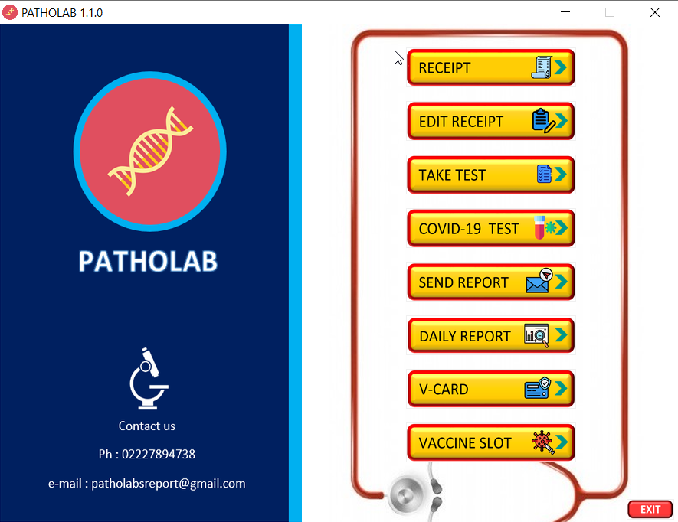**HOME PAGE   
 FIG 1.1**

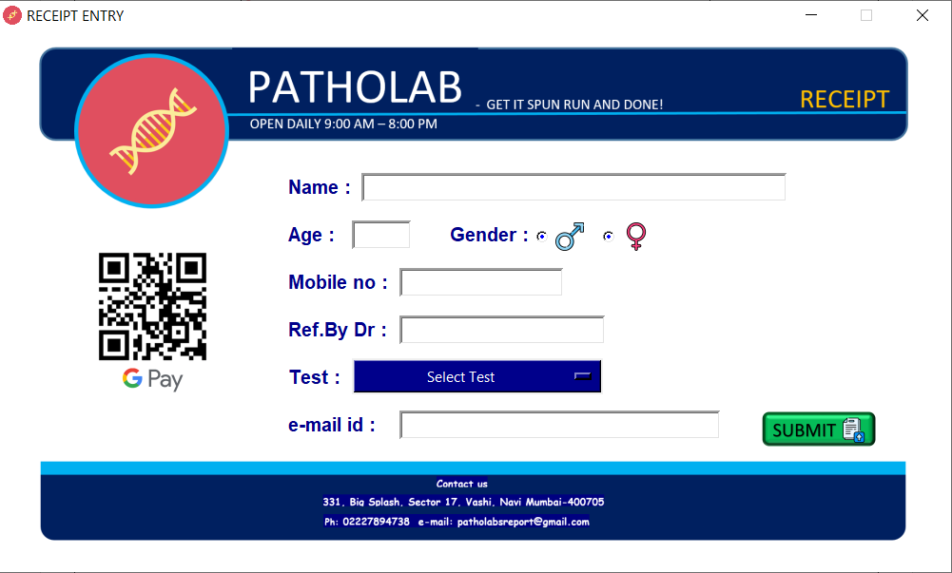**RECEIPT WINDOW  
 FIG 1.2**

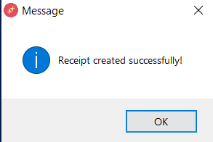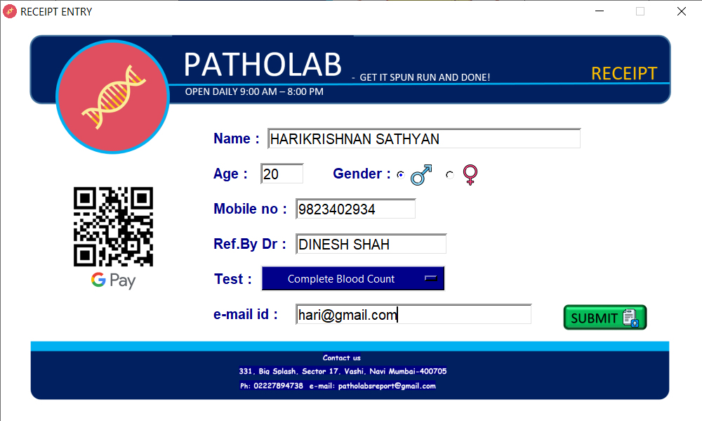**After inserting the values, click submit.**  **FIG 1.3 FIG 1.4**

**Display receipt**

**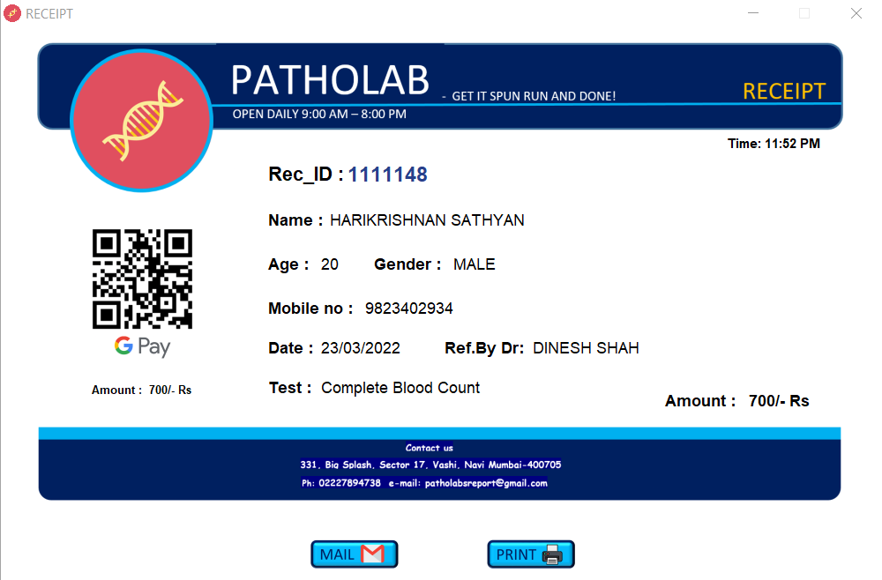  
 FIG 1.5**

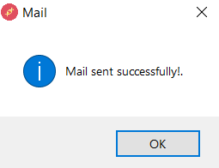**After clicking on mail  
 FIG 1.6**

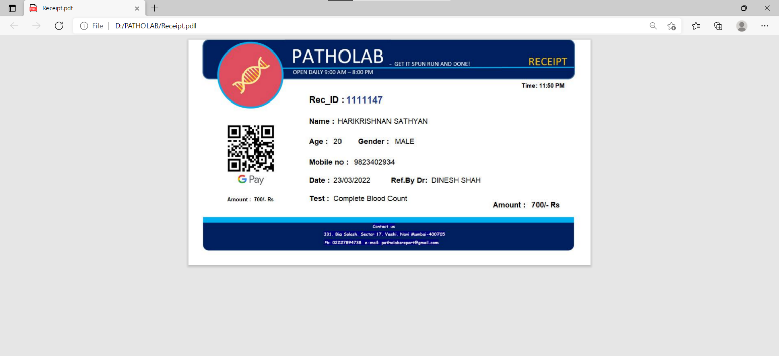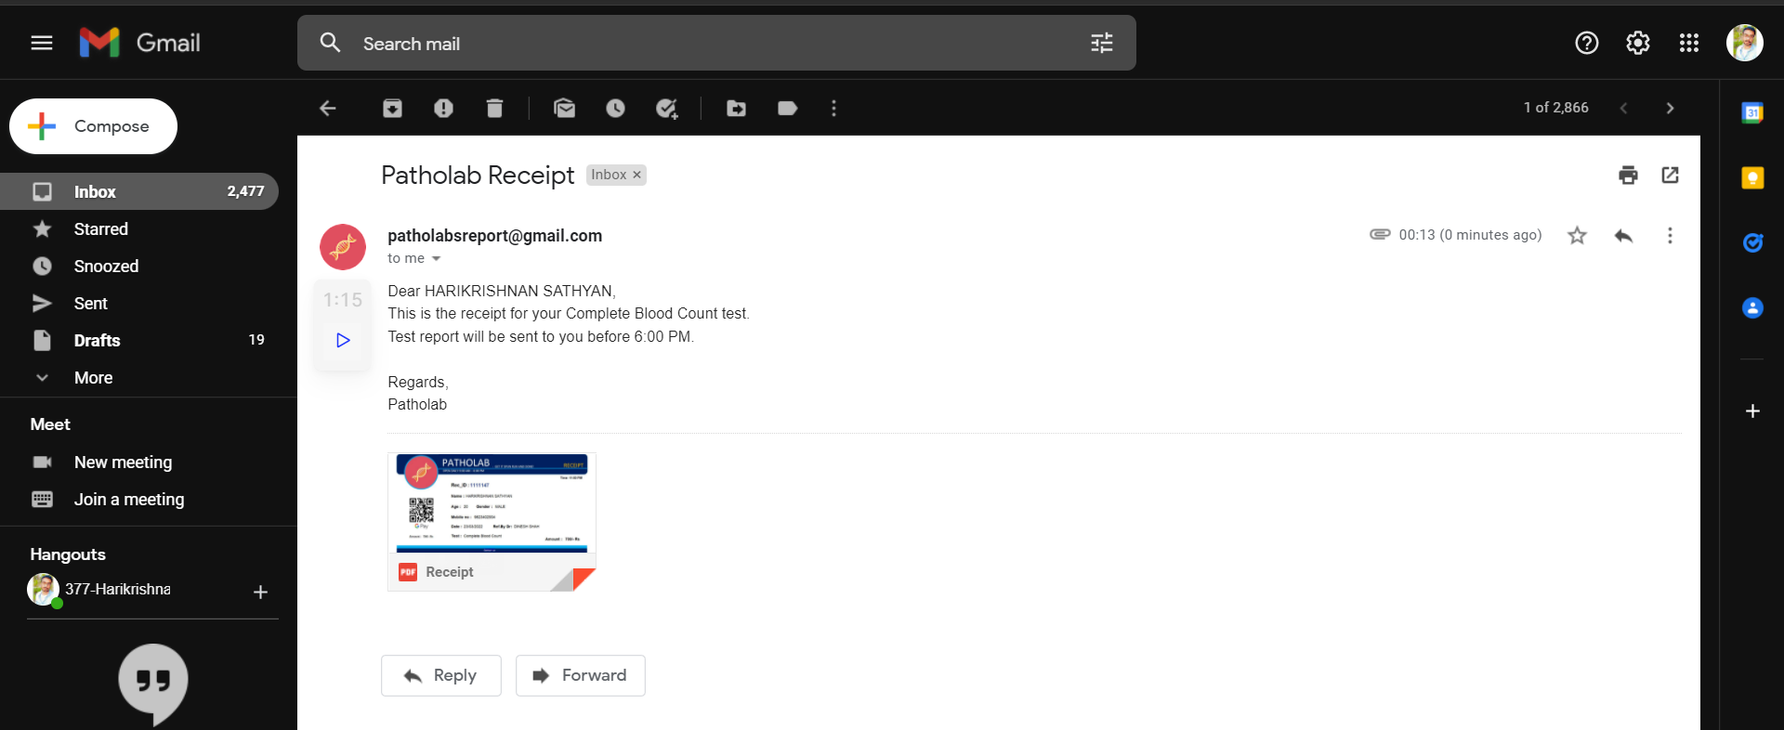**Received mail  
 FIG 1.7**

**After printing**

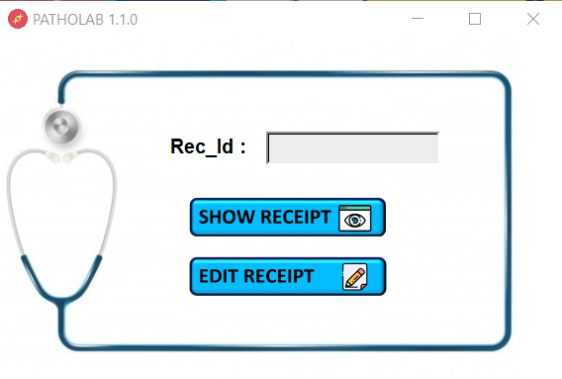 **FIG 1.8  
Edit Receipt window**

**FIG 2.1**

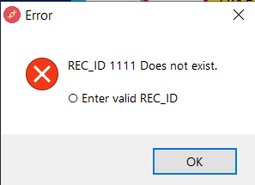**After writing invalid id   
 FIG 2.2**

**Show Receipt will display the receipt as shown in FIG 1.5. & can perform functions from FIG 1.5 to FIG 1.8**

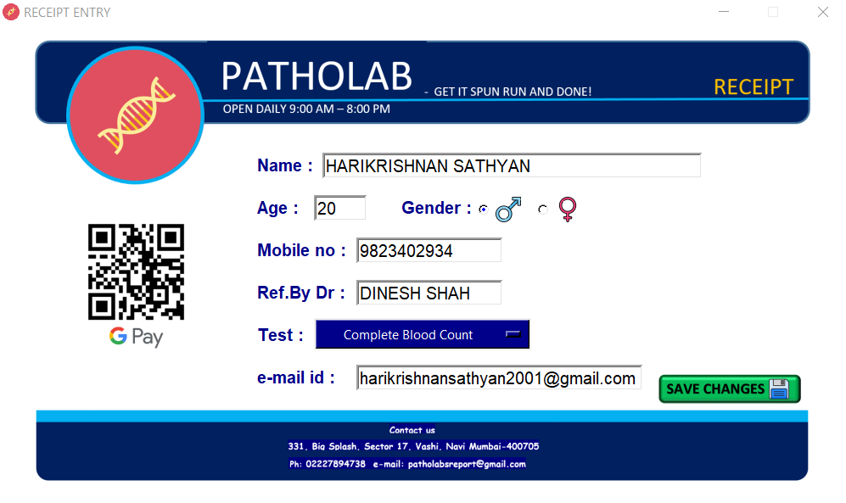**Clicking on Edit Receipt  
 FIG 2.3**

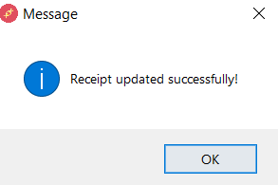**After editing click on save changes**

**Receipt will be display the receipt as shown in FIG 1.5. & can perform functions from FIG 1.5 to FIG 1.8.**

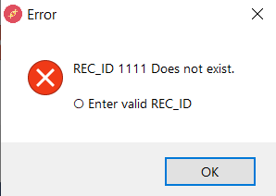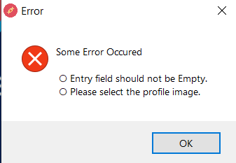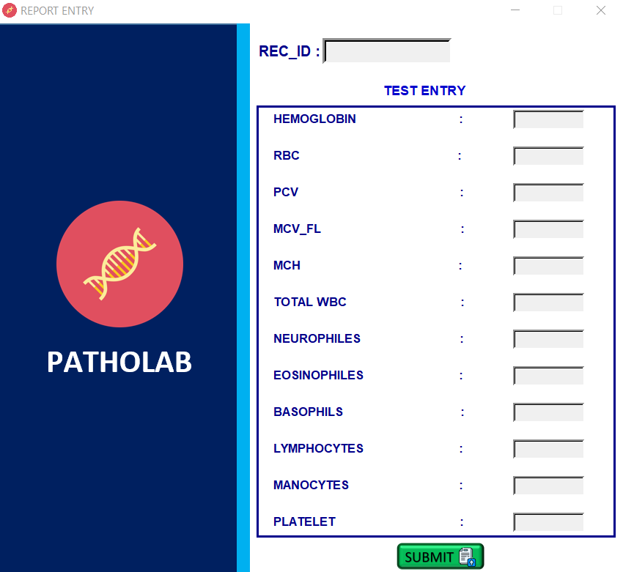**Take test window  
 FIG 3.1  
  
Entering invaild details will display the following message**   
  
 **FIG 3.2 FIG 3.3**

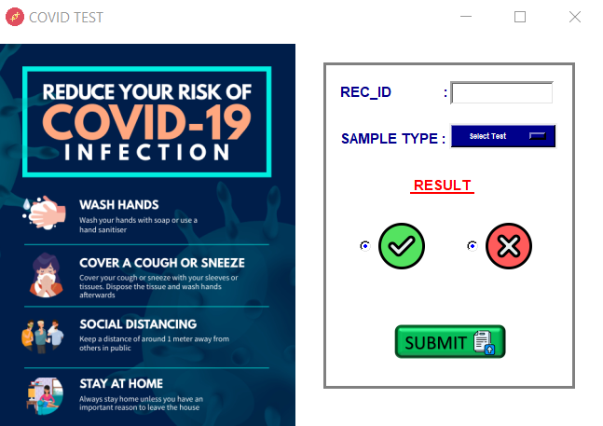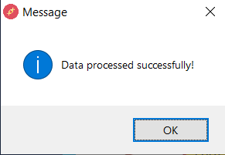**After inserting details  
 FIG 3.4  
Covid-19 test window  
 FIG 4.1**

**If invalid details or fields are kept empty**

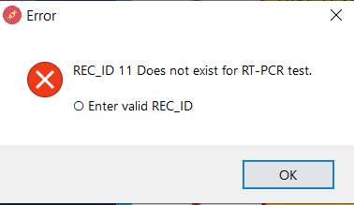 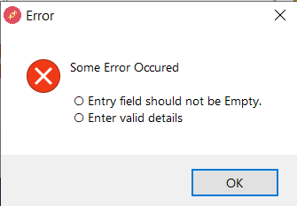  
 **FIG 4.2 FIG 4.3**

**After entering valid details**

**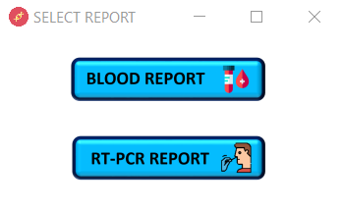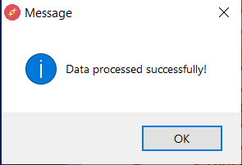  
 FIG 4.4  
  
Send Report window  
 FIG 5.1**

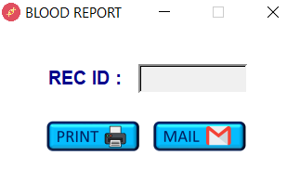**After clicking on blood report   
 FIG 5.2**

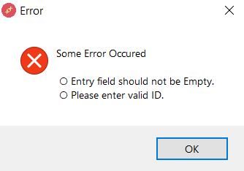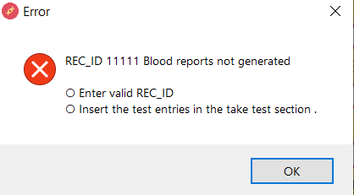**If invalid details are entered**

**FIG 5.3 FIG 5.4**

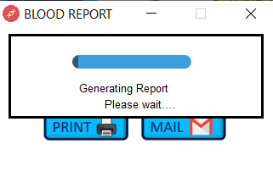**After clicking on print button  
 FIG 5.5**

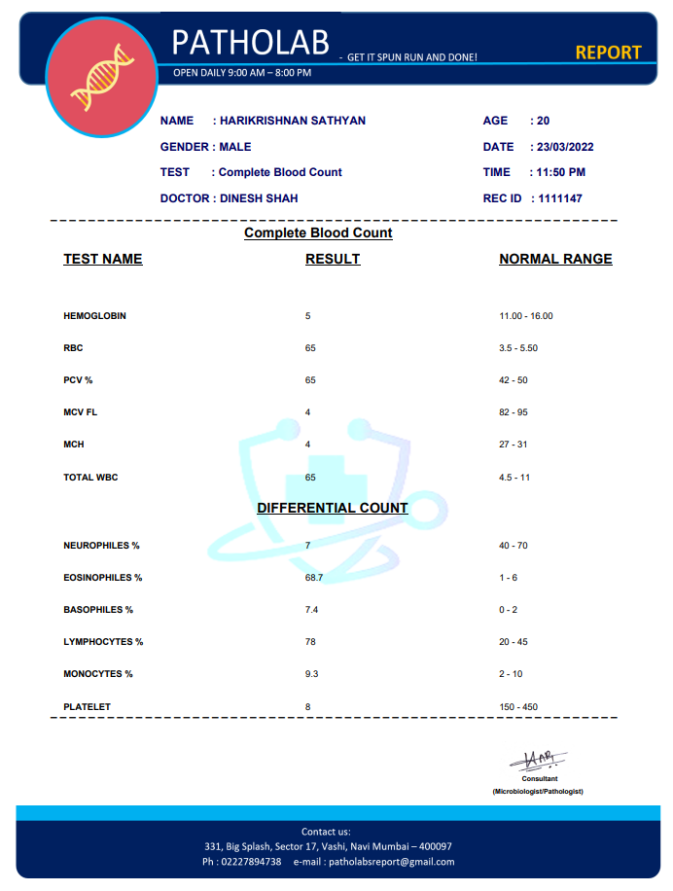**Report will be generated   
 FIG 5.6**

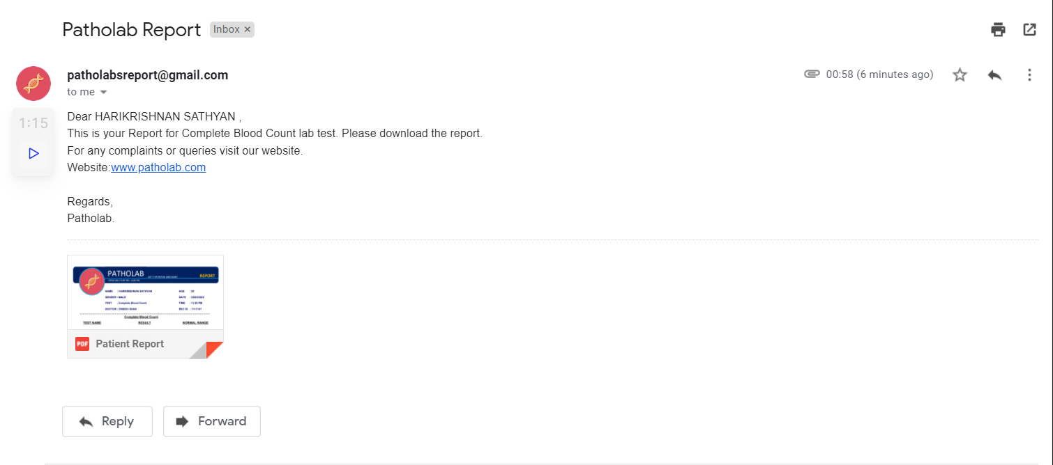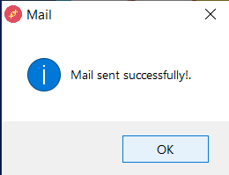**After clicking on mail button  
 FIG 5.7**

**FIG 5.8**

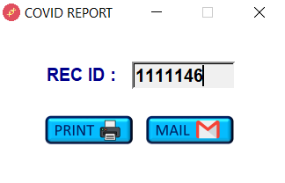**Clicking on RTPCR report will open the below window  
 FIG 5.9**

**Entering invalid will pop up messages as shown in fig 5.3 and 5.4.**

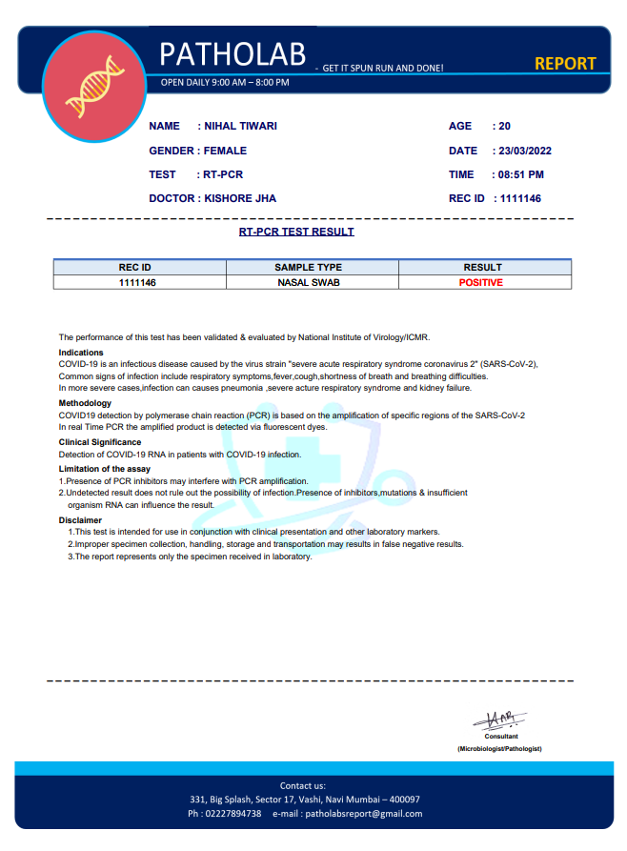**After clicking on print, Covid report will be generated  
 FIG 5.10**

**Clicking on mail will send report as show in fig 5.7 and 5.8**

**Daily Report window  
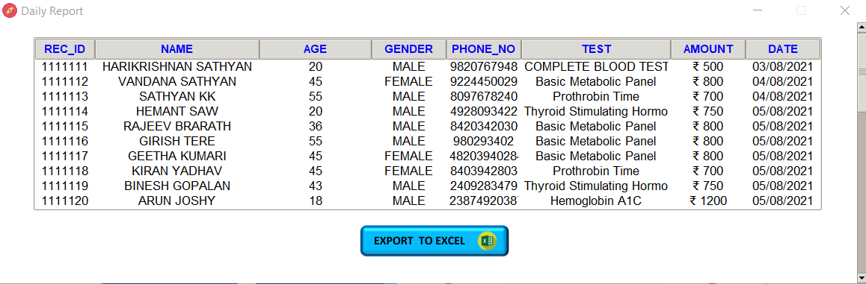  
 FIG 6.1**

**After clicking on Export to Excel**

**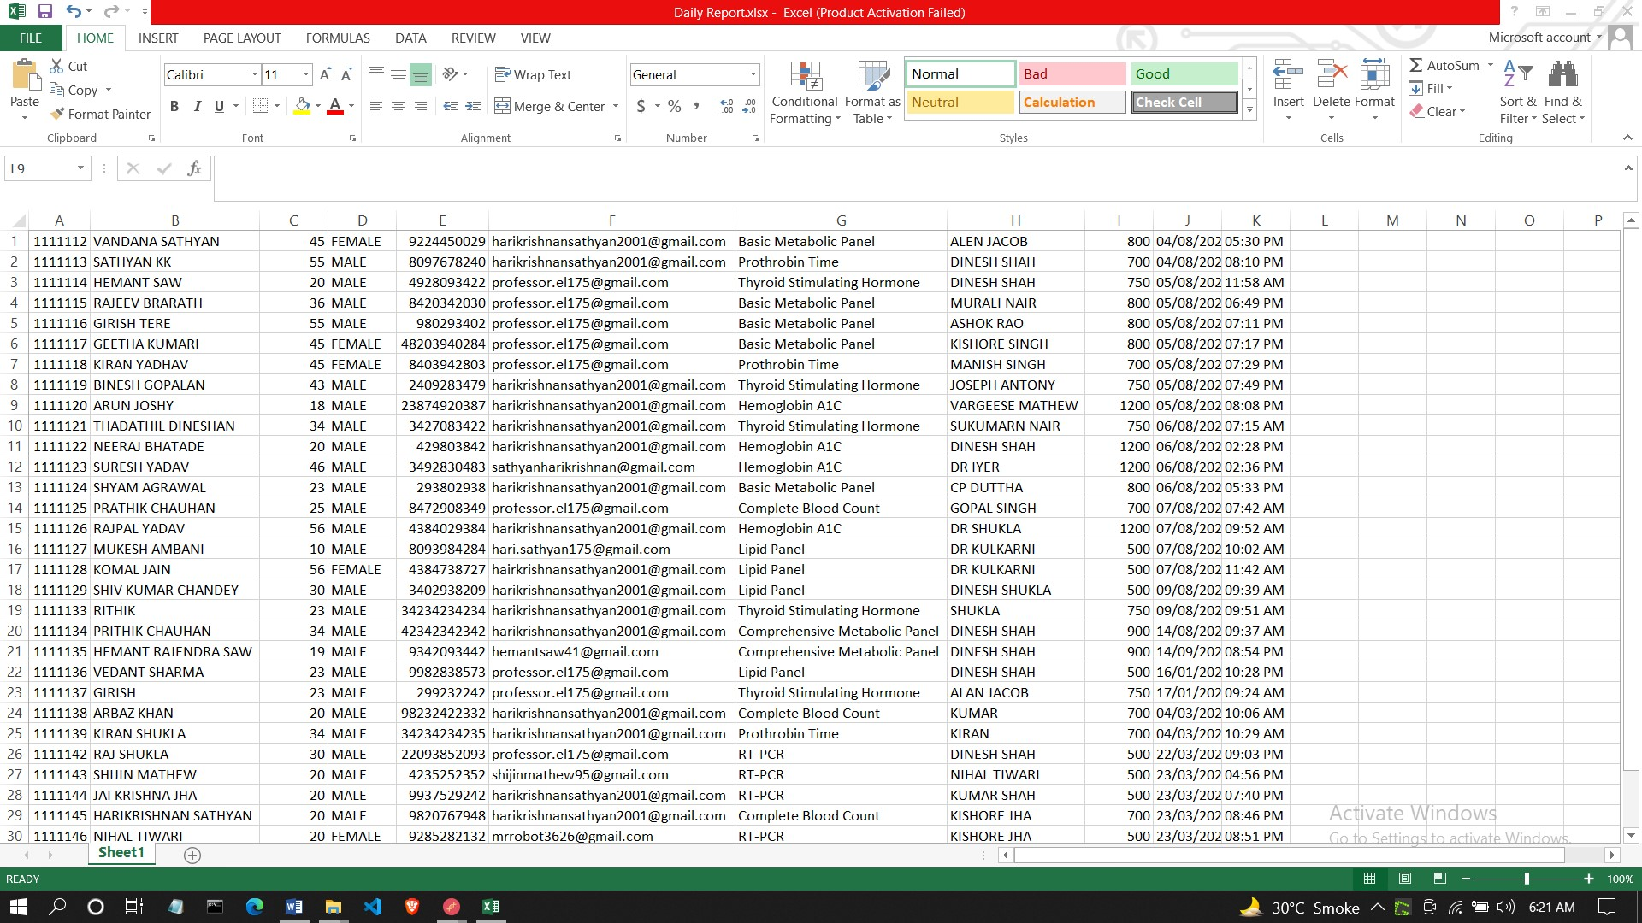  
 FIG 6.2**

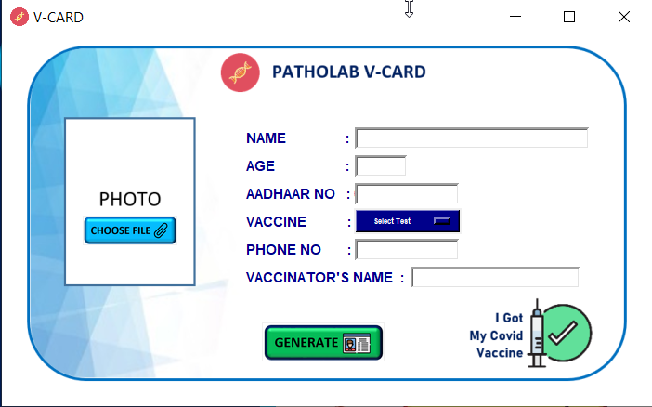**V-CARD Window  
 FIG 7.1**

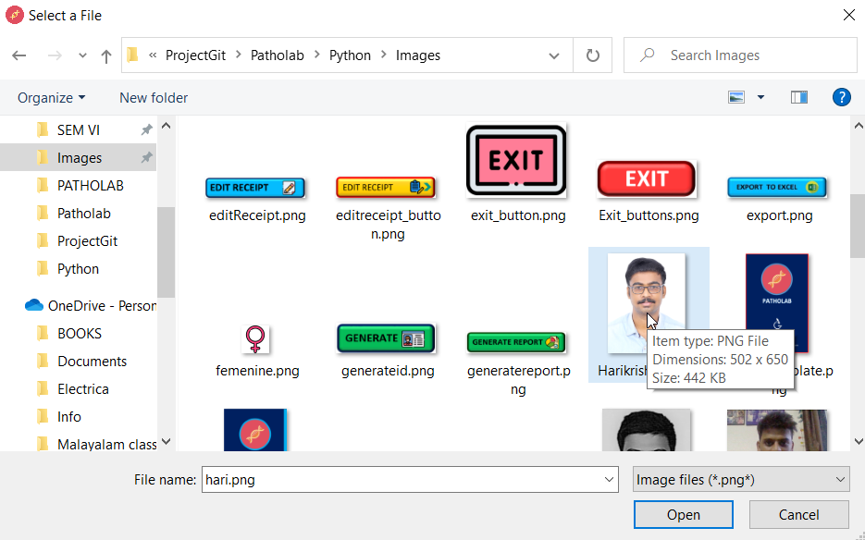**After inserting values select choose files and browse the your image  
 FIG 7.2**

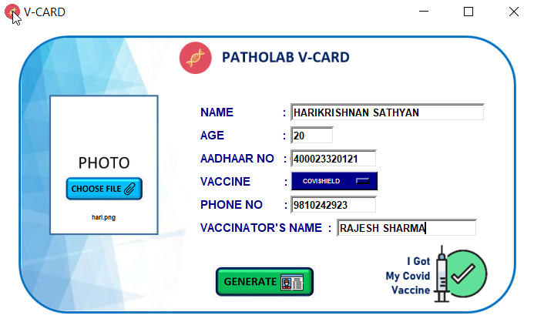**After choosing the image click generate.  
 FIG 7.3**

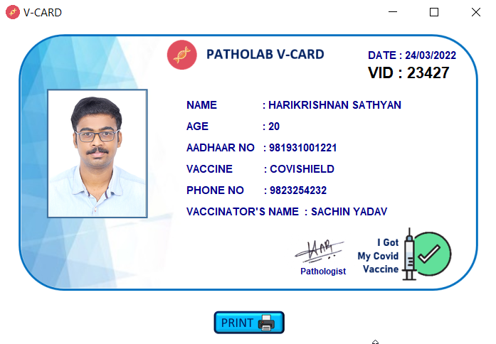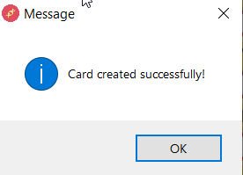**Card generated successfully message will popup.  
 FIG 7.4  
After clicking ok V-CARD will be displayed.   
 FIG 7.5**

**Clicking on print button will print the V-CARD**

**FIG 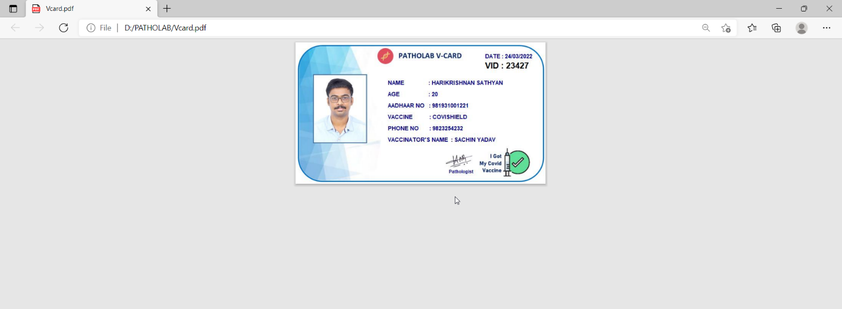7.6**

**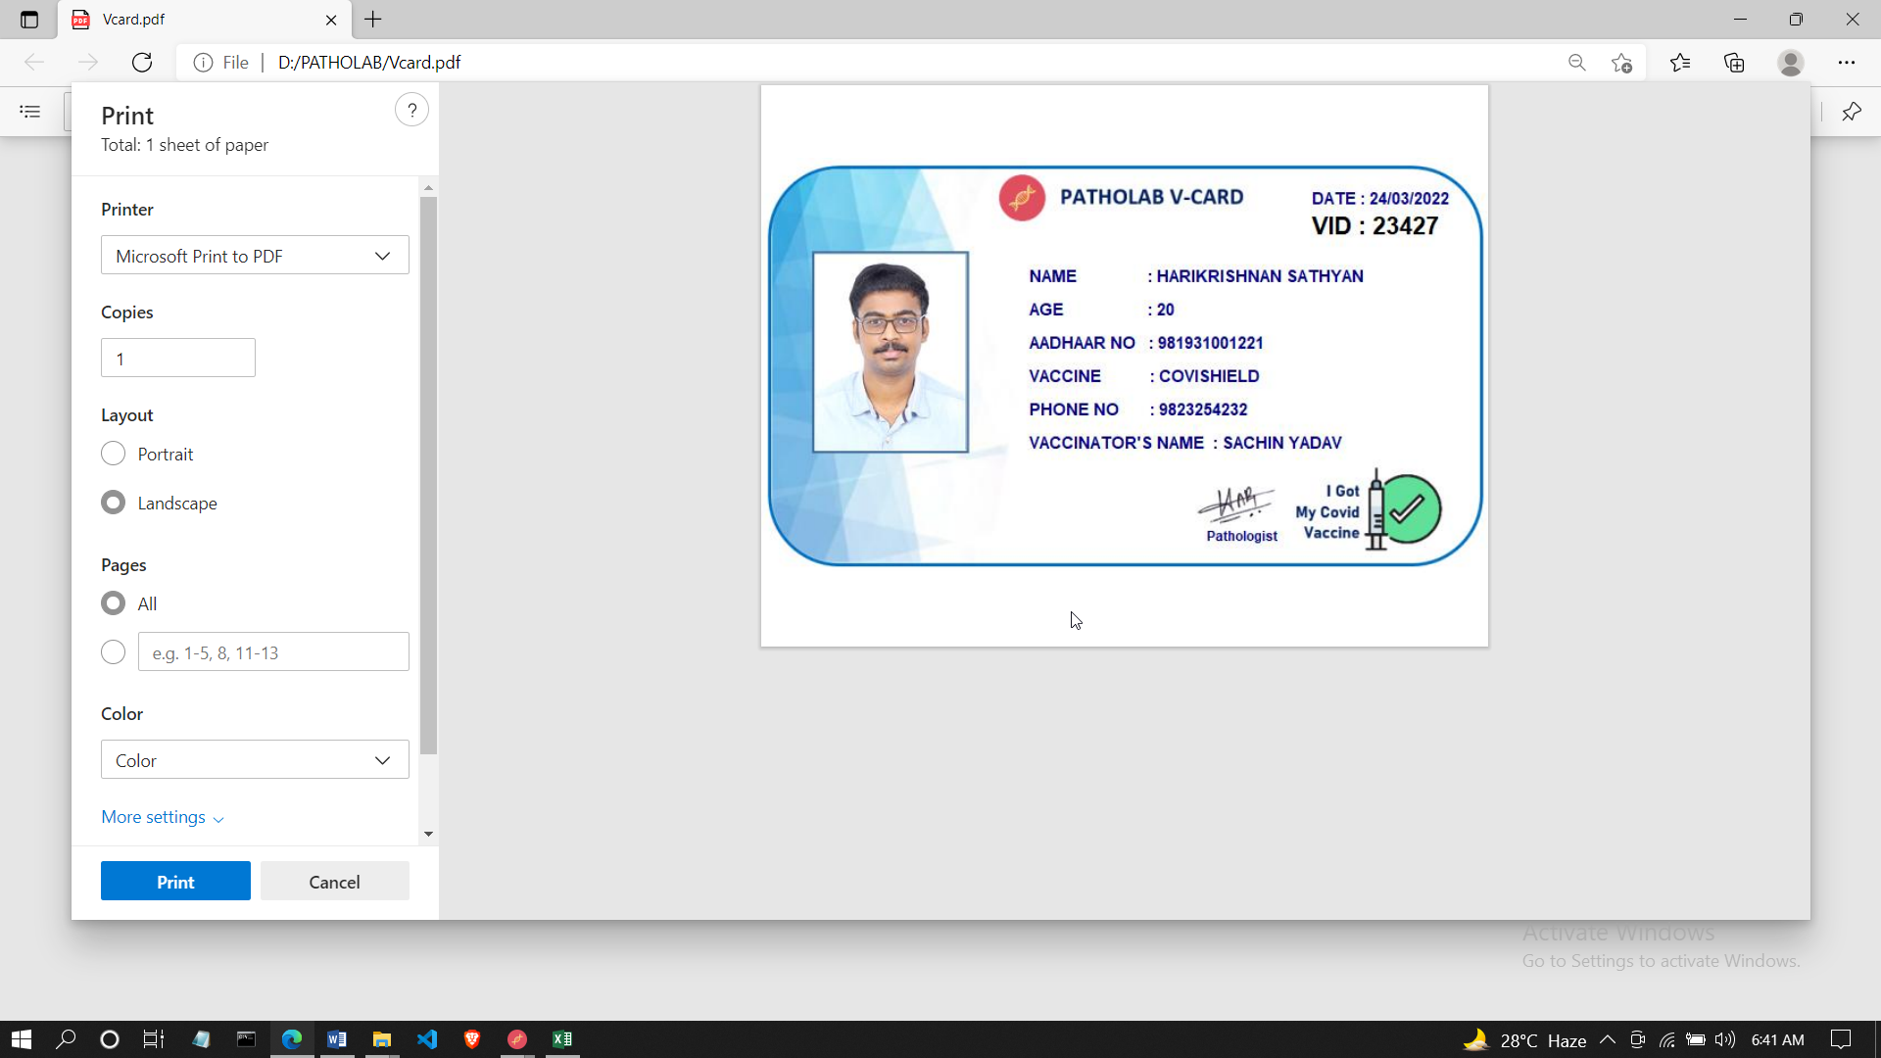  
 FIG 7.7**

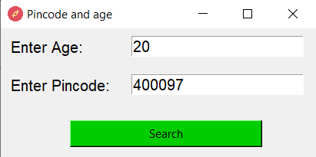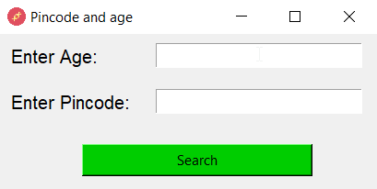**Vaccine slot window  
 FIG 8.1 FIG 8.2**

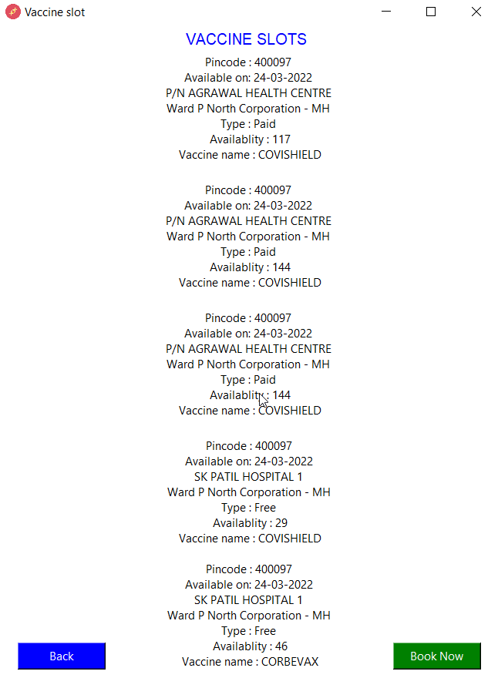**After clicking on search button.  
 FIG 8.3**

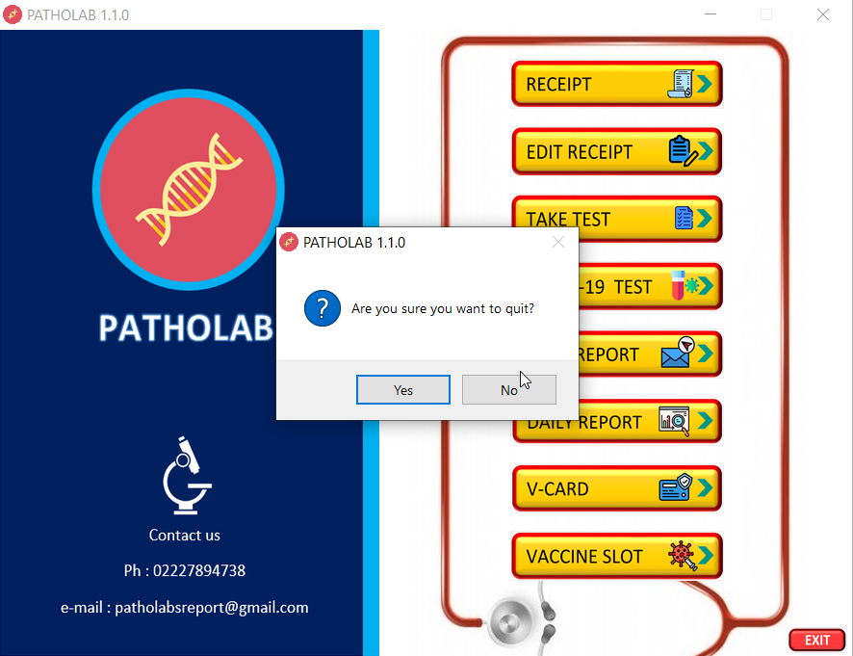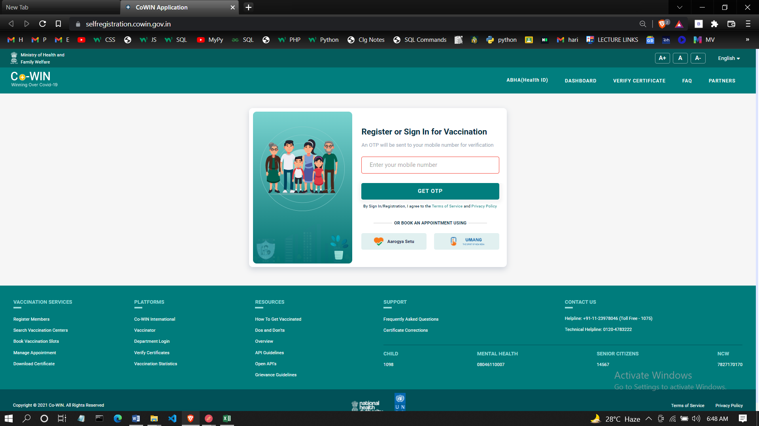**Clicking on booknow will redirect to slot booking site  
 FIG 8.4  
  
  
After Clicking Exit button in HOME PAGE  
 FIG 8.5**

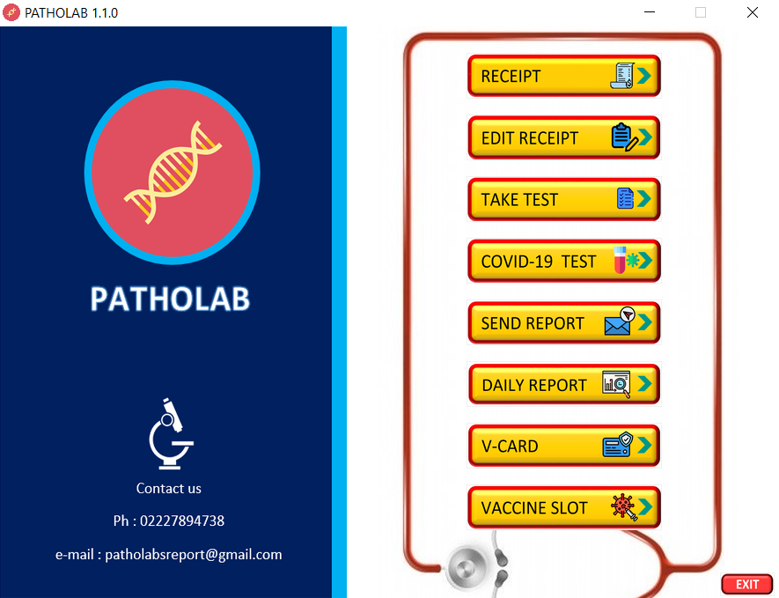**If clicked yes then sofware will be closed else the sofware will remain as it is.  
 FIG 8.6**